COVER

A review of Control Room system in AEC Industry

# Abstract

AEC Sector is notorious for its over-budget, project delay, high Injuries and fatalities rate resulting from work place accidents. As widely acknowledged by many experienced project engineers, managers and client, it is attributed to poor collaboration between project stakeholders, time waste caused by poor management on data and lack of insight to set-up safety strategies and policy . The poor performance of these parameters will inevitably affect the entire project, thus leading to poor project delivery.

With the sector is embracing the digital age, the processes involved in the design, construction and operation should be enhanced by technologies dealing with value-added monitoring of data and optimisation of a centralised system to solve these problems.

In this study, literature review and research on the available solutions on the market is conducted, it shows that theoretical frameworks for the control room has been discussed by many literature but there is less research focusing on practical demonstration of a control room solution. A demonstration prototype should be developed to show how the control room built based on that theoretical framework and what is its requirement, functionality, and limitation.

Four core techniques have been embodied in the application framework of the control room: (1) Collaboration Platform, (2) VR, (3) Dashboard and (4) Real-time Web Viewer Application. This exploratory study aims to elaborate how to apply these techniques to verify the state of the art of Control Room system by making use of the currently available solution on the market and reviewing these available solutions. The detailed implementation process and case studies have been presented.

The result shows that existing solution like BIM 360 collaboration platform can provide an effective collaboration of modifying the model data with different project team members. The VR viewer is good for site safety training and carry out design review meeting remotely. The power BI dashboard can provide insight from the safety and progress related data. And the web viewer application can capture the sensory data of a working environment at real time for the mangers to understand whether the environment good for the workers to work.

This paper could act as a starting point to pave the way of a control room which implemented in the future. The potential development of the control room can be much further investigated.

Declaration

Table of Content

List of Figure

List of Table

Abbreviation

Acknowledgement (to different software/ service provider)

# Introduction

# Overview

Architecture, Engineering and Construction (AEC) sector is one of the largest sectors in the global economy. There is about $10 trillion spent on construction-related activities over the world annually, which is equivalent to 13 percent of GDP. There is also 7 percent of working population around the world working for this industry (McKinsey & Company, 2017). However, the productivity of AEC Sector is lagging the global productivity by over 30% and 98% of infrastructure projects are over budget or delayed around the world (Changali et al., 2015).

As AEC sector is complex and dynamic in nature (Mohd Nawi et al., 2014), it consists of multiple disciplines and teams at various stages such as planning, design, construction, and operation. The parties are mainly client, designer, contractor, and manufacturer who are involved from the beginning until the completion of the project. Over the years, the project delivery practice among these parties are notorious for poor in collaboration such as isolation of working and inadequate co-ordination. As the project is delivered in a sequential manner, it would significantly affect the quality, safety and the progress of the works in future stages.

Apart from that, the information management in construction is not effective enough. The AEC Sector is labour-intensive and generates enormous amounts of information including calculation, drawings, project reports, tender documents, ...etc which are produced in the planning stage to the operation stage. According to a research in China (Xu & Luo, 2014), it has identified and discussed many consequence on the poor collaboration and information transfer among different parties, such as the loss and inconsistent of information caused by fragmentation of parties and unorganised information system. There is a comprehensive statistic shows that around 43%, 12%, 3% of the project time lost due to inconsistent information, dislocation, and ambiguity respectively on a construction project in average.

Health and safety deficiency are also one of the main concerns as compared to other sectors. The AEC Sector has long been recorded with the highest number of death and accident rate compared with other industry sectors globally. For example, it is about 79,000 construction workers suffered from health issue by working (new or long-standing) and 30 fatal injuries in 2018/19 (HSE, 2019). There was also about 2.1% of construction workers suffering from musculoskeletal disorder that they noticed that they got it during working. The rate is statistically significant than the rate for workers of other industries (1.2%) [ibid].

# Technology Implementation in AEC Sector

As the AEC sector is embracing the digital age, the processes involved in the design, construction and operation should be enhanced by technologies dealing with value-added monitoring of data and optimisation of engineering systems. However, the AEC Sector is notorious to adopt new technology and digitalisation much slowly compared with other industry. The digitalisation index of construction is very low as shown on below figure (McKinsey, 2015).

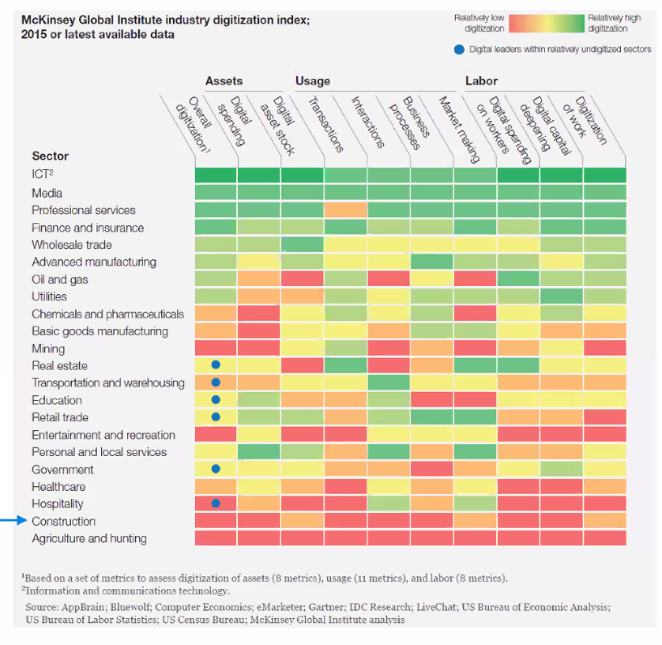

Although the sector has recognised the need for change and adopted many technological solutions such as Building Information Modelling, Virtual Reality, ..etc , they are fragmented point solutions and disorganised (Woodhead et al., 2018). To improve the construction project delivery by technology with a long-term advantage, a “planned IoT ecosystem” approach rather than combining different “point solutions” is recognized. This system should be with high connectivity between hardware, software and making key decisions based on data (ibid).

Besides, as the explosion of global pandemic COVID-19 is accelerating the development of digital transformation in different industry. With unprecedented consequences such as the disruption of manufacturing and supply chains, the mitigation to the impact by COVID-19 requires new approach of working and forms of collaboration such as remote working among team members to increase overall resilience of the business by using technology.

# Smart City and Digital Transformation

Nowadays, the concept of smart city is common to all of us over the world. The smart city framework focus on connecting all the ‘things’ effectively with linking the interrelationships between multiple city systems, so that the output can be efﬁciency multiplied (Cosgrave, 2017). Besides, there are 3 elements highlighted for smart cities (Harrison et al., 2010), which are instrumented, interconnected and intelligent. Instrumentation means capturing the data from the physical world by sensors; interconnection means the data should be integrated from different source and they can communicate each other, while intelligent means the data should be visualised and provide insight for making better decision.

Apart from that, to resolve the long-established barriers in AEC Sector, an initiative Project 13 has been risen under the smart city paradigm to develop a new business model for the infrastructural projects. It is an industry-led response to delivery models that not just for the stakeholders as mentioned, but also the citizens of economic infrastructure. It aims to develop a new business model to increase certainty, productivity and improve outcomes from the project life cycle. And most importantly, Digital transformation is a key enabler of this new business model. (Radford, Jamie; Macdonald, 2020).

Regarding to this, the building process should also have a revolutionary change to construct a smart city under this initiative. Can we utilise a optimised engineering system so that we can effectively control and get insight from the information generated to improve the project delivery?

This study will make use of current services and software available on the market to build the prototype of such kind of Control Room system. The functionality and visualisation techniques of this system will be evaluated to investigate what functionality of a control room should be provided and how it can be improved.

# Scope of Research

The major scope of research of this study is as follows:

* What types of collaboration tools and visualisation technique should be used for the Control Room to give insight and improve the project delivery?
* How does the control room work to solve the long-lasting problems of infrastructural projects in construction stages?
* How should the Control Room be improved upon review on the current solutions on the market?

# Literature Review

# Control Room

The control room concept was originated in 1970s, the launch of Apollo 13 program by NASA. The engineers on the ground control room needed to response the changes swiftly to the space vehicle and the astronauts exposed to the extreme conditions in outer space. Later, NASA identified that they can no longer make corrective decisions based on the original modelling method because the actual module had subjected to significant changes due to the exposure under extremely hostile environment. It was necessary to update the original modelling method so that the actual state of the module could be closely simulated. As a result, they used the “pairing technology” to simulate the outer space with the mathematical models so that the engineers and different professional could collaborate in the control room on ground and made decision based on that mathematical model (Jarrett Hendricks, 2020). It set the basis of the well-known paradigm “Digital Twin” in recent years.

# Control Room in the Industry

The concept of control room can be applied in different industries. There is an Africa’s bank illustrated that they make a good use of this concept[1]. The head of the compliance control room of this bank suggested that the awareness of using a control room function as part of the larger compliance function has raised sharply in the financial services industry because the regulation become more strict and the day-to-day operations of the institutions become more complexed (StarCompliance, 2019).

The purpose of the Control Room in this case is to monitor the sensitive corporate information flow from a multi-service financial institution. Control rooms can act as a company’s nerve centre to monitoring the deals data such as mergers and acquisitions, equity offerings, debt offerings, …etc. The deals themselves are very complicated and generate an enormous amount of data that must be monitored closely to ensure the deal data can be organized, recorded, and analysed. It is also necessary to keep track on who are involved in the deal, what are their deal and who agree with that deal, there is extremely little room for error for the deal data (ibid).

On the side of construction stage for infrastructural projects, it generates enormous amount of information. A control room should also be used to enhance project management to reduce risk of project delay, within budget, and minimise contractual implication as well as health and safety of workers as they are susceptible to hazardous situations. The Control Room can give insight to the project stakeholders on all aspects of health and safety before and during the construction works and allocate the resources and planning the project schedule effectively.

# Digital Twins

The concept of Digital Twin originated from the NASA’s Apollo project. It’s main point is to creating a virtual asset to represent the physical assets, which helps to make better-informed decisions to improved outcomes in the real-time (Bolton et al., 2018). Simulation and analytics can be done by the digital twin, which established a continuous improvement to the physical asset by measuring performance, design based on data-driven observations, continuously making decision to cater for the changing market conditions (Jarrett Hendricks, 2020).

In AEC industry, many professionals embrace the use of Building Information Modelling (BIM) with the adoption of Digital Twin paradigm to form an integrated approaches on micro (construction site) and macro (city districts) levels (Boje et al., 2020). Since the BIM provides a digital model and data schemas with a standardised semantic representation of building components and systems. (more…..)

These literatures have pointed out that the control room should with digital twin as the basis and it should be linking with the BIM model in the AEC industry. However, as it is only the theorical framework and there is less focus on how these control room solution should be implemented and how it works practically, so there is less study to evaluate the functionally and identify the requirement and limitation and whether it is easy to adopt this types of solution in the industry.

# Components of Control Room

Regarding to the above mentioned research gap, this section try to outline the practical application framework of the control room to enhance collaboration between project team members and get insight from the data by different data visualisation techniques.

# Cloud & Collaboration Platform

A cloud-based common data environment should be used as a centralised collaboration platform to foster the collaboration and information exchange between different disciplines. Cloud computing changes the traditional way of businesses to manage IT resources, which the services such as servers architecture, databases, analytics and business intelligence over the Internet (“the cloud” ) and ensuring data security (Microsoft, 2020). Cloud Computing also eliminates the requirement of using local hardware to handle and process data, thus no need to pay extra cost to buy hardware with high computation power (Stergiou et al., 2018).

Besides, traditional tools such as email, project management software and telephone are just one-way communication activities. They lack the real-time collaboration elements which is for connected engagement, discussion and approval process (Levine, 2016). If different parties in the project can submit updates of information on a simple and real-time manner on a single platform to create a single source of truth, it will be easier for all project team members as one and remain on the same pace as the project proceeds, so it would not make the progress delay in terms of scheduling and over-budget due to rework.

# Visualisation – Immersive Virtual Reality

Immersive Virtual Reality (VR) can give the user feel like physically presenting in a computer-generated environment simulating places in the real or imagined worlds. It is common used in the education and training purpose by its potentials of provide an interactive and motivated environment (Freina & Ott, 2015). Besides, many publications have identified that VR technologies have been implemented to enhance safety in many areas, such as risks identiﬁcation, workforce training, skill transfer, ergonomics in the AEC industry (Li et al., 2018). While VR can also be used for meeting with team members to work together within a 3D model for discussion, which is benefit for remote working (Brandon, 2020).

# Visualisation - Dashboard

Dashboard visualisation is a cognitive tool to improve our “span of control” over the business data. This help the user to identify trends, patterns, and anomalies from the data. They help manager to reason about what they observe and as a guideline for them to make effective decisions. It also let non-technological users to combine multiple data sets easily to customize a dashboard and generate data visualizations. Besides, Key performance indicators (KPIs) is commonly used to benchmarking and compare performance by meeting both strategic goals with a dashboard in different industry. Construction industry can also make use of the objective benchmarks and to measure excellence across the industry. The analysis result can help to improve the building processes, risk identification for project delivery. It is the topmost priority for Project Directors, Project Engineers and any other person responsible for planning management to implement a better planning process by having a clear view of the project’s status.

# Visualisation - Real-time Web Model Viewer

As suggested by (Boje et al., 2020) , Digital Twin should be based on a semantic web approach to accelerate digitalization by narrowing the gap between the physical and virtual world. Semantic web approach is to enable IT systems to process information by connecting web sites and data resources such as IoT devices so that the relationships and dependencies between pieces of data can be recognised (Keil et al., 2019). As a result, a web site approach to link the digital model data and the data from IoT device will be investigated.

# Open API

Under the context of smart city, the availability of information can create opportunities to get insight from the city's activities through modeling and analysis of data from different domains (Belizario & Berardi, 2019). This smart data solution can be used to get insight and able to manage cities data strategically (ibid). As a result, the Control Room should consist of a common data exchange standards and open Application Program Interfaces (API) for third-party developers to develop external applications (Woodhead et al., 2018). It makes more similar solutions can be developed and connected together to improve the functionally of the entire control room system and make good use of the data.

# Methodology

Multiple services and software available on the market to build the prototype of a Control Room system. The functionality and visualisation techniques of them will be evaluated to investigate what functionality of a control room should be provided and how it can be improved.

# Framework of Control Room in Construction

The hierarchy of the framework for the Control Room composed of 3 layers which are the Data Layer, Data Services and Application layer. The entire ecosystem is shown as the below figure:

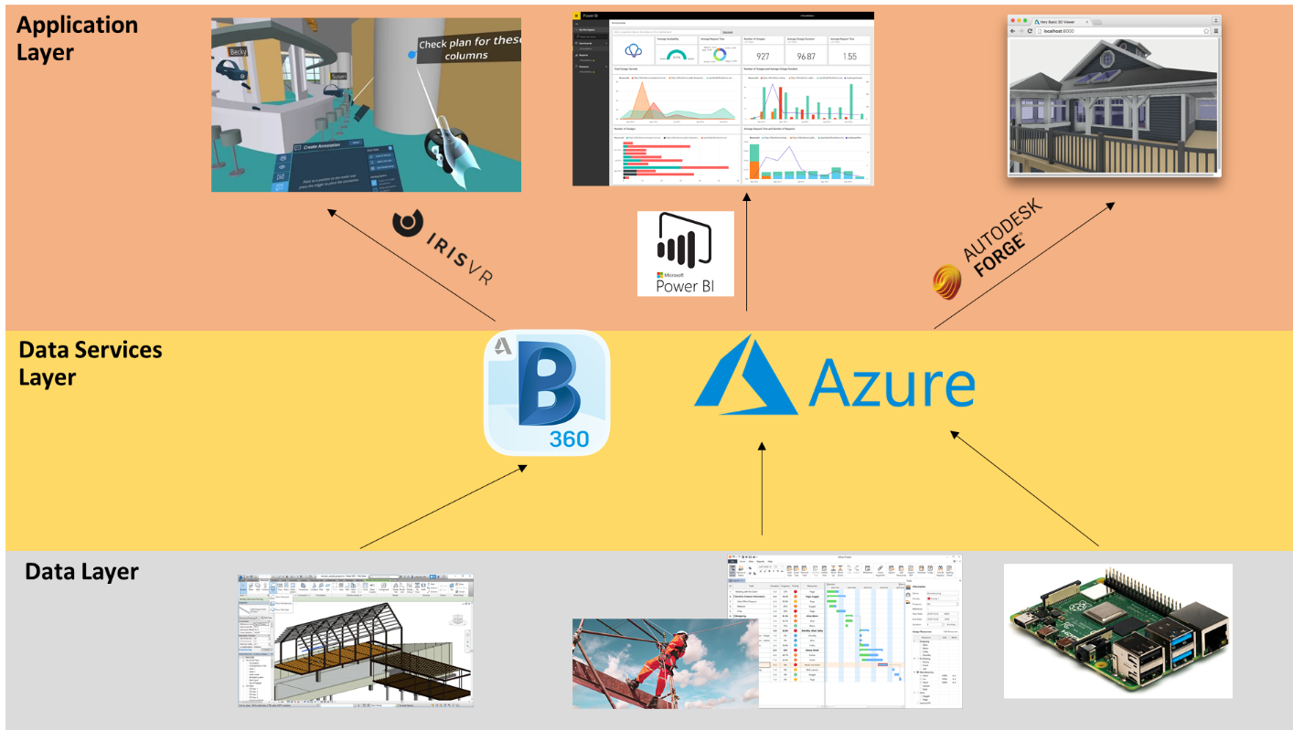

# Data Layer

Each of the component (from left to right) in the data layer represents an aspect of the construction site to reflect the performance.

1. Model data: the virtual model of the physical configuration of the building or infrastructures
2. Project performance data: Safety and Progress related data
3. Sensory data: Working condition of the construction site

# Data Services Layer

It forms the core part of the Control Room. The model data can be published to the BIM 360 platform for collaboration so that different project team members can work remote and modify the model data on a single source of environment. Besides, the Microsoft Azure Services provide a platform to storage and process the data. The project performance data and sensory data will be stored in a SQL Server database which is created with Azure Services. The data can be retrieved to feed into the elements in application layer for visualisation.

# Application Layer

The Application layer is for data visualisation. Model data in BIM 360 will be visualised in VR environment with the software “Prospect” developed by IrisVR. The project performance data will be visualised as dashboard by Microsoft Power BI. While the sensory data will be visualised with the model data on BIM360 by Autodesk Forge API.

# Source of Data

# Model Data

The model data is a digital prototype of a residential house, which is a template file provided by Autodesk Revit 2020 and in format of “.rvt”. The 3D model can be visualised as the below figure:

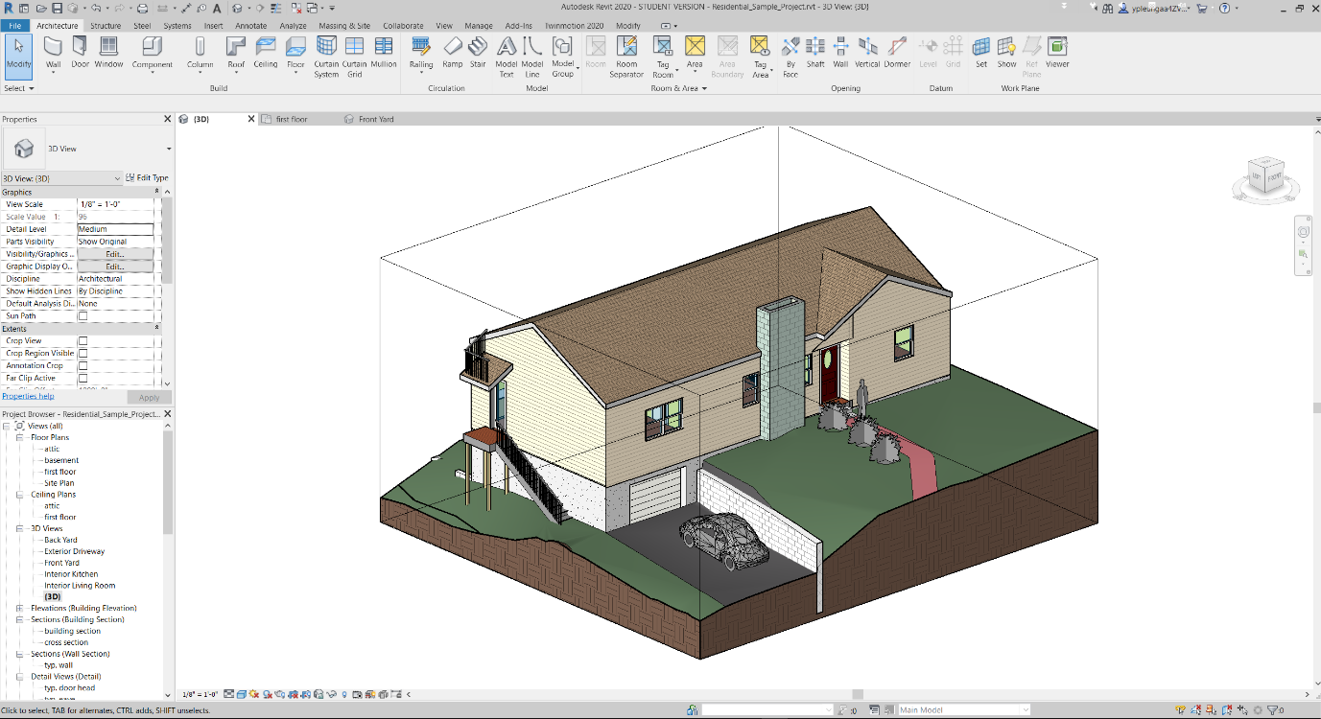

The model contains objects data relating to the architectural and structural elements. All objects in the model contained information such as object name, type ID, furniture name, material information and major dimensions in object property.

The model data will be published to BIM 360 to simulate the collaboration between the structural and architectural team. Details will be discussed on session 4.3.1.

# Project Performance Data

Datasets of project performance data used for this study is taken from the ‘Project Hack’ hackathon organised by Project Data Analytics Community. The data has been modified for visualisation purpose only.

The first contains all incident record of a construction site ranges from 2012 to 2017, it includes detailed information with 1023 rows and 26 columns, such as date of accident, accident category, nature of injury and damage classification and type of contact.

The second contains the handover record for different rooms and area of a construction site, it includes information with 193 rows and 16 columns, such as code for the room/area, handover date for stages 1-5 and handover status.

# Sensor Data

Low cost microcontroller Raspberry Pi (RPi) has been selected as the prototype of IoT devices to capture the construction environment data. RPi is a Linux-based platform. It is a credit card-sized computer and can be as an alternative of a desktop computer. As it is low cost and support different operating systems, it is suitable for ranges of projects such as acting as IoT device. The version used in this study is the Raspberry Pi 4 Model B which is newly released on the end of May 2020. The RPi can connect with local area networks with WIFI and transfer the data received from the sensors to Microsoft Azure IoTHub services, which will be explained in Section 4.4.1. The technical details are given in the below Table:

Table: Technical specification of Raspberry Pi and sensors

|  |  |  |  |
| --- | --- | --- | --- |
| **Sensor** | **Data to capture** | **Image** | **Technical Data** |
| SHT20 | Temperature,  Humidity | SHT20 溫濕度傳感器模組I2C 通訊- 台灣物聯科技TaiwanIOT Studio |  |
| PMS3003 | PM2.5 | Laser Particle Concentration Dust Sensor Pm2.5 Plantower Pms3003 ... |  |
| MH-Z19 | CO2 | 100% New&original MH Z19 MHZ19| | - AliExpress |  |

Figure to show final configuration of the Raspberry Pi with sensor installed.

# Field Info

To simulate a working condition of a construction site and the ability of the sensor to collect the empirical data, the sensory system was installed on a local factory in Hong Kong. The following sections describe the approach to install the system.

->Site Description

->how sensor set up and collect data in the factory, install location plan

-> description of the parameter range

# Statement of Ethics

All the data used in this dissertation do not contain any personal information and Project hack has granted consent to me for using their data for dissertation purpose. Therefore, no ethics approval was required. (Github link: )

# BIM 360

# BIM 360 Collaboration

BIM 360 will be used to simulate real-time collaboration, the modules of this cloud platform such as Document Management, Design Collaboration and Project Management modules will be used for explore the functionality on multi-disciplinary coordination on all project information. Drawings, model data and relevant files uploaded on BIM360 support version control with the help of module Document Management. Design Collaboration module can show the different drawing packages at different time created by different parties and will allow them to decide whether to consume that package for their further amendment. The data also supports requests for information (RFIs), submittals, inspections and more will the module Project Management. (details of ISO19650 workflow)

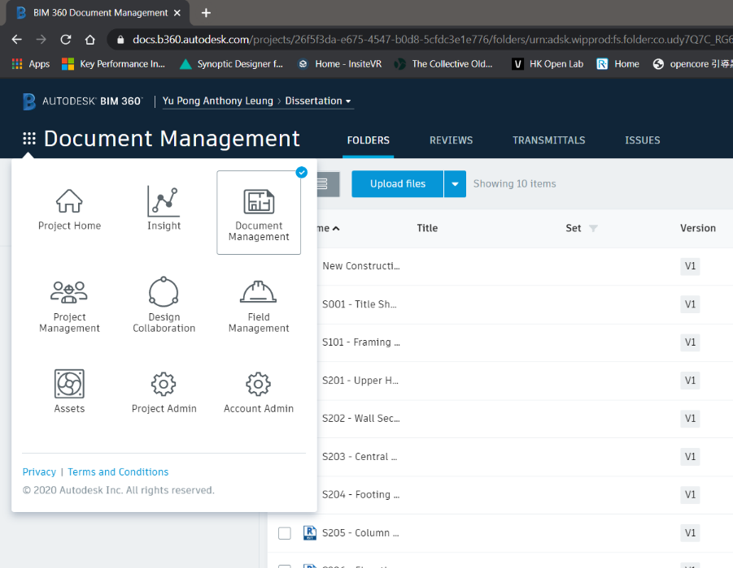

# Forge API

To retrieve the data from BIM 360, the Autodesk Forge API has been used. It comprised of multiple API’s, each one dedicated to a specific group of tasks related to the Autodesk cloud ecosystem. The data in BIM360 such as model data, checklist, issues and so on can be further developed for automated processes, workflows and data visualisation. All the available API can be explored on forge.autodesk.com.

# Microsoft Azure

Microsoft Azure offers cloud service in three main categories: Infrastructure as a Service (IaaS), Platform as a Service (PaaS), and Software as a Service (SaaS). PaaS will be focused on this study. Platform as a service (PaaS) is a cloud-based development and deployment environment, with resources to deliver our own applications. PaaS not only includes the elements of IaaS such as servers, storage, and networking, it also provides middleware, development tools, business intelligence (BI) services, database management systems, and more. It is designed to support the full development of the lifecycle of a web application like building, testing, deploying, managing, and updating. PaaS enable the author to manage the underlying application infrastructure and middleware of the development tools and other resources easily. Besides, Azure cloud services offer a free tier one-year subscription to their services for students. The services can also be purchased as pay-as-you-go basis.

# Data Capture and Storage

Data has been sent over to Azure for interception and storage in a database for management, analysis and visualisation. For the sensory data, the sensor with the microcontroller Raspberry Pi (RPi) act as a node and registered as an ‘IoT devices’ in Azure. By using the IoTHubs services as the gateway, the data can be further processed as below figure referenced from the Microsoft Azure Cloud.

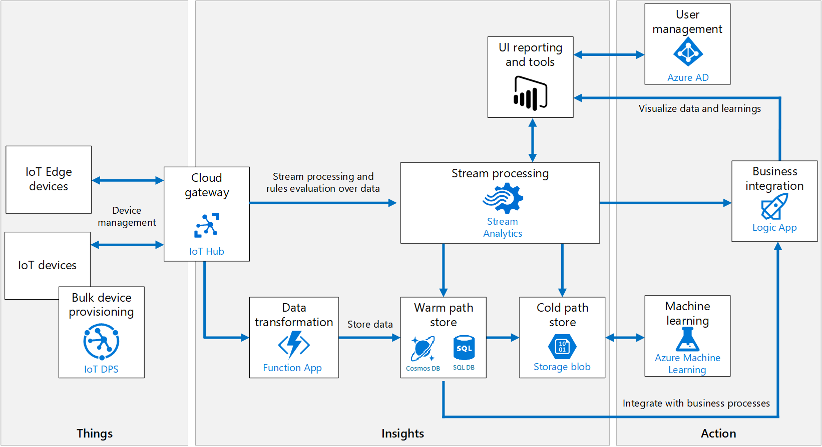

# Database Management

Azure SQL Database is a fully managed PaaS database engine that handles most of the database management functions such as upgrading, patching, backups, and monitoring without user involvement. With Azure SQL Database, a highly available and high-performance data storage layer for the applications and solutions can be created. It also allows the process of both relational data and non-relational structures, such as graphs, JSON, spatial, and XML. Data in file format like .csv can be moved to an Azure SQL Database using a Bulk Insert SQL Query.

A python script (Appendix XX) was used to insert the performance dataset which is in .csv format. It established a connection to the SQL Server with the required credentials and perform inserting to the database. Python Libraries such as panda and pyodbc will be used for data processing and building connection with the SQL Server.

|  |  |  |  |
| --- | --- | --- | --- |
| **Table Name** | **Field** | **Type** | **Description** |
| SAFETY |  |  |  |
| PROGRESS |  |  |  |

# Streaming of Sensory Data

Besides, Azure Stream Analytics is a real-time streaming engine that is designed to process high volumes of fast streaming data from multiple sources simultaneously.

Once the relationships between input sources RPi in IoTHubs and output sources such as SQL Database has been formed, it will trigger the streaming of real-time sensory data from IoT device to SQL Database. The Python script (Appendix xx) has executed on the RPi to connect with the IoTHubs. RPi is set to send data every 10 seconds. The parameters obtained are the microcontroller device id, timestamp, temperature, humidity, CO2_level and PM2.5_level. These parameters are added as a new row in the Azure SQL Server database.

In summary, there are 3 tables which are the safety data, progress data and sensory data of the data layer for the control room.

|  |  |  |  |
| --- | --- | --- | --- |
| **Table Name** | **Field** | **Type** | **Description** |
| SENSORY |  |  |  |
|  |  |  |
|  |  |  |

# API Endpoint

Azure App Service is an HTTP-based service for hosting web applications, REST APIs, and mobile back ends. Node.JS application has been developed to retrieve the data from the SQL Server Database. The script is on Appendix XX. It defines an URL endpoint for triggering GET request from the tables in SQL database and returned as a JSON object for live data visualisation and analytics. Data can be retrieved from these API for the visualisation applications. The API documentation can be found on the studies GitHub page.

# Visualisation Techniques

# VR

The plug-in of Autodesk Revit called “Prosepct” which is developed by IrisVR will be used for VR visualisation, the model data in BIM360 can be opened in Revit and the model will be converted for VR visualisation by using this plug-in. The 3D Views of the model can be imported directly into VR and automatically become viewpoints. It can create a narrative for the VR experience which is in 1:1 scale. The immersive VR headset Oculus Quest will be used for this study. It is a completely wire-free, PC free and with all the sensors built in. The specification is as follows:

|  |  |
| --- | --- |
| Display panel | OLED |
| Display resolution | 1440 x 1600 per eye |
| Refresh rate | 72Hz |
| CPU | Qualcomm Snapdragon 835 processor |
| RAM | 4GB RAM |
| Battery | Lithium-ion battery with 2-3 hours playtime, depending on what you are playing |
| Degree of Freedom | 6 degrees of freedom head and hand tracking |
| controllers | Two touch |
| Weight | 571g |

# Dashboard

A dashboard application was built on top of Azure SQL Server Database to provide data visualisation and analytics. Microsoft Power BI will be used to visualise the construction performance data as a dashboard. As Power BI can get data from different source, data can be retrieved from Azure SQL database after the connection has been set up. Whenever the data has been sliced or another field has been created for visualization, Power BI will make a query to the database to get data.

# Web Viewer

The Web-Application was to provide a plug-n-play tool for user from any background to understand the working environment of the construction site with the visualisation of a digital model and sensory data. The BIM 360 APIs of forge API will be used to develop a viewer application to visualise the model data in BIM360. The viewer application is a WebGL-based, client-side JavaScript library for 2D and 3D model rendering. The model data will be first translated to SVF using the [Model Derivative API](https://forge.autodesk.com/en/docs/model-derivative/v2/) of BIM360 APIs. Once the process has completed, the viewer will be able to visualise these translated files.

# Besides, the real-time sensory data will be visualised with JavaScript library D3/Chart.js on the page with the model. New data streams can be added dynamically. The chart will automatically update the new data series into the available space in the SVG.

Then, the website will be deployed to Azure. (details…..)

# Result & Discussion

Originally this study intended to invite different construction professionals to use the application of the control room to make this study have more personal feedback and comments. However, under the current disruption by the COVID-19 pandemic, it is hard to carry out such activity. As a result, the performance of the control room system will be presented by the author self-experience on how the data can be used by different applications as mentioned on Section 4.

(Put video and the link of the Control Room)

# BIM360: (how to collaborate with the BIM model)

The BIM model data first opened in the local desktop software Autodesk Revit for modifying the design such as add additional structural elements like beams, columns and walls. Then the model can be uploaded to the “Document Management module” of BIM 360 by a one-click button in the Revit. This module provides a version control for model data, what have been updated in each version and tracking who have modified the model. The model in the cloud platform can also be compared together and the difference can be highlighted. It provides a good way for the managers to easily identify how the design has been changed due to construction constraints, which raise the awareness to the update of information.

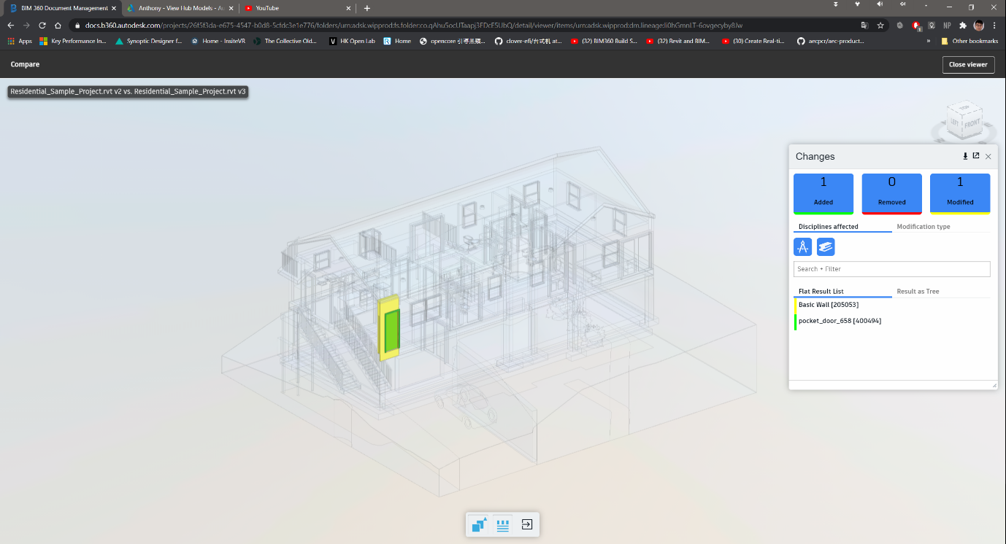

Besides, the “Design Collaboration” module has been used to see how to enhance the collaboration of team members and the information management. The structural team members can make use of the ‘Link Revit’ function in the local desktop software Revit to consume the finalised model from other team members such as the architectural team. After that, the structural team can design the structural elements such as beam, columns and walls based on that model. After that, the structural team can synchronize and publish the finalised model to the BIM 360. Later, the structural team can create a package in the timeline as shown on below figure so that the packages can be shared to other team members to consume this model and keep on modify it. This is the concept of the design collaboration loop, which provides a continuous and smooth handover of the model data between different team members, which enhance the collaboration and information management (figure).

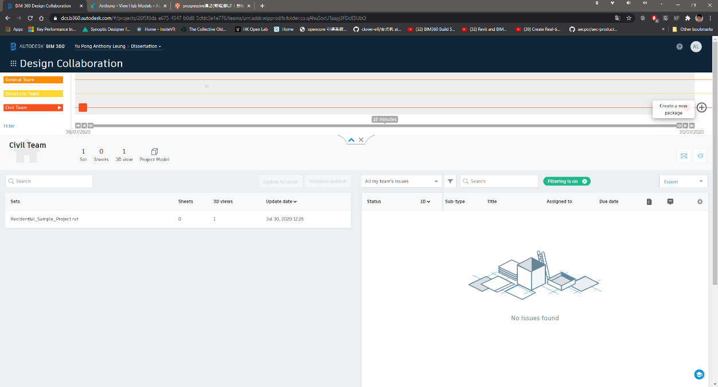

# Management of Issue

Besides, different team members can raise RFI, issue to the model by using the project coordination module….

# Drawbacks

The design collaboration module is effective for the collaboration of team members. However, it is a bit complicated and it created multiple model data files which may lead to confusion. For example, after the publish of the model data by one team member to the BIM 360, the model will be saved in the folder of “WIP (Work in Progress) folder”, which is created automatically under the work breakdown structure of the design collaboration module. Besides, as the user need to create a package to share to other team members, the model data will be saved in “Shared” folder for sharing to other team members for consume. And finally, after the model has been consumed, the model will be saved in the folder named “Consume”. As a result, multiple model data files have been created by using this design collaboration loop concept and it may make confusion to the beginners that they do not understand which model is the latest one and which model they should be used if they are not familiar with the design collaboration concept.

(multiple file format) Besides, separate to different software and file format (rvt, nwc, nwa), easy to confuse

# VR

# Case Study: Project Coordination & Training

By using this VR visualisation to the model data, the author can fully immerse in the 3D models data. The author find that this kind of VR visualisation gives a great perception for the project team members to understand the construction environment than traditional drawings. Different team members can carry out remote VR design review meeting to collaborate each other and understand the need other team members.

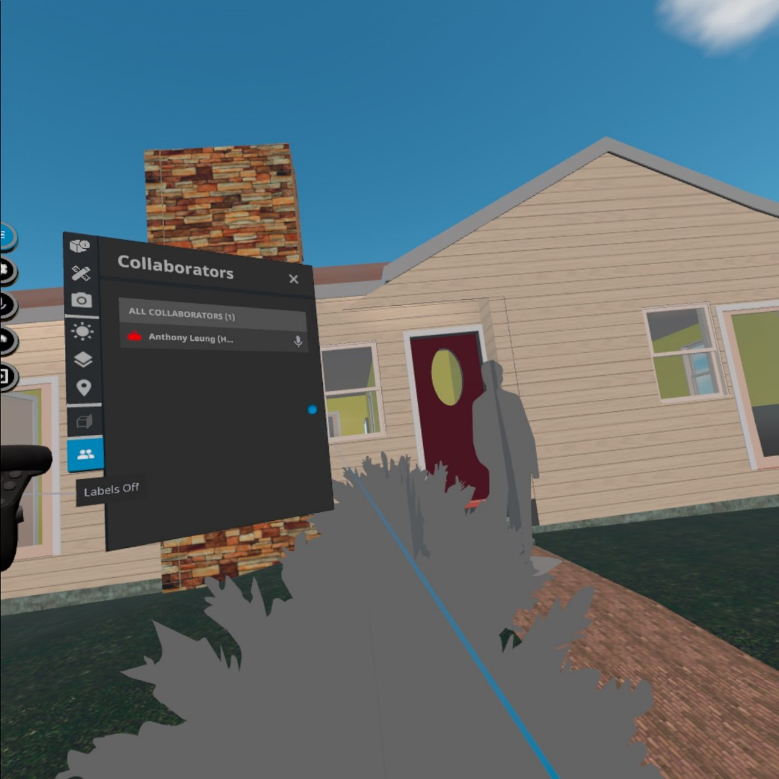

After they all have agreed how they would modify their design or the construction sequence in the VR meeting, team members can combine with the use of design collaboration module in BIM360 to consume the BIM model from other team members for further modification. As a result, different team members can modify the model effectively and avoid crash of elements or design fault, which greatly increases the productivity. Combining the VR visualisation method can greatly unleash the potential of the collaboration tools of the Control Room.

Besides, as many literatures already suggested that VR has a great use in education and training purpose (Alizadehsalehi et al., 2019), it is a good tool for using in safety training purpose. As the user can visualise the model from it very beginning to the final completion stage. All the safety hazards during the construction can be identified and find out the exact locations with the high risk of safety deficiency such as confined space, locations which easy to fall from height. For example, some location such as the outer stair from the model which is above ground for xx meters and at the edge location, which is highly susceptible to the hazard of falling from height. As a result, the managers can arrange special training and pay more attention during the construction of that stairs.

# Drawbacks

VR can provide a great immersive experience for the users. However, the subscription cost is quite high and often exists as a separated plug-in or services rather than integrated with the collaborate tools. It made individual need to pay extra cost to buy this service to use, which lower the motivation for the construction professionals to adopt this technology. According to two services providers like “IrisVR” and “the Wild” which can function as a plug-in with Autodesk BIM360 and Revit. Their monthly subscription is about $225 USD and $295 USD, which is not an affordable price for some company especially some small size company to adopt this solution.

Besides, taking the VR plug-in by “IrisVR” as an example, one must need to open the local desktop software Autodesk Revit to load the model data from the cloud BIM 360, and use the VR plug-in in Revit to transfer the BIM model data its external VR software “Prospect” to parse the model data so that we can visualise the immersive VR environment on the external software which shown on the below figure. It is quite not user-friendly. (charts of that software)

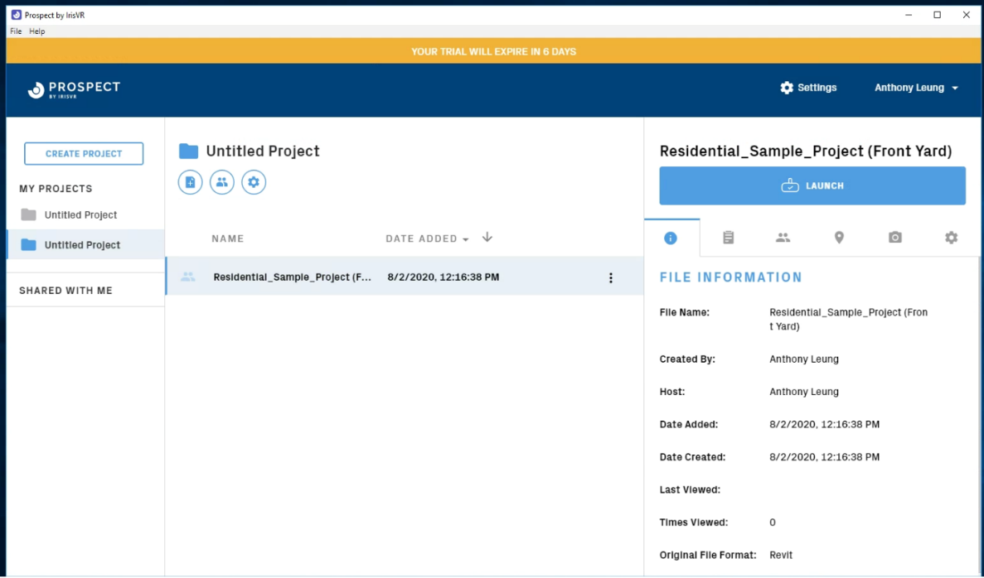

To make it more user-friendly, it should be integrated in the cloud platform of Control Room (such as the BIM 360), so that when all the project team members access to the cloud platform, they can open the model file and then press one button to access the immersive VR environment for walkthrough and remote meeting immediately rather than installing external software and so many steps to start with the visualisation with VR.

# Dashboard

# Case Study: Safety Data to identify critical safety record

A dashboard has been developed based on the modified data sourced from HSE. It is an interactive dashboard to visualise the details of the safety accident record across 2012 to 2017.

In the first dashboard, we can identify the trend that the number of accidents is decreasing across the years and Area B with the highest number of accidents. One can choose whatever categories under different indicators such as “severity”, “age band”, “main activity”, “Risk Category” and “Injury Type” so that the total number of fatalities, incidences and the number of accidents across different years will be changed. It is easy to identify most of the accidents belongs to the activity of M&E installation , category of risk with slip or trip on the same level, workers suffering from body parts such as lower limb and the age band susceptible to accident belongs to 25-34. According to these messages provided by the data via the dashboard, the project managers can make decision like paying more attention to the activity of M&E installation and putting more training to the workers aged with 25-34.

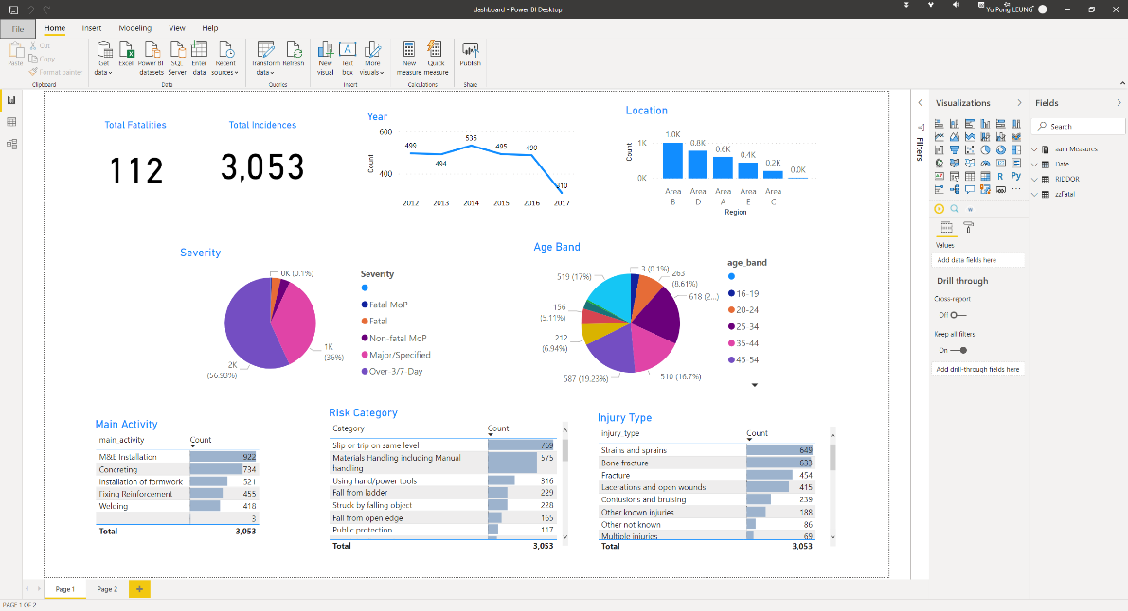

Besides, the second dashboard use a tree level diagram to visualise the number of accidents. The tree diagram separated into different levels, the first one is “severity”, second is “injury type”, third is “location” and the last one is “main activity”. For example, when we selected one of category under the first level “severity”, then the number of accidents will be separated into different groups under the second level “injury type’”. And then it will separate into different groups under the third level “Location”, when we click one of the group, the number of accidents will be separated in different groups again under the forth level ‘main activity’, so that we can identify the number of accidents based on different level of a specific root.

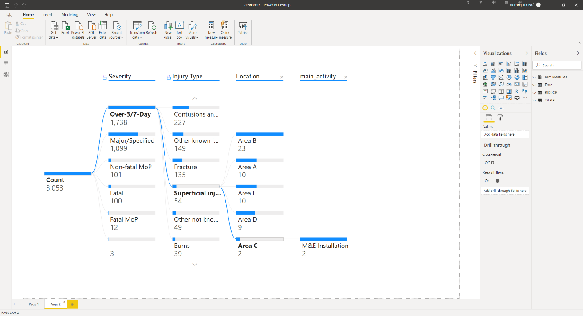

# Drawbacks

The Power BI is a great platform to present the data to give insight, patterns or abnormality. However, as AEC Sector is a complicated and complex industry, it is quite difficult to standardize a database schema format for data visualization. Since different construction company will have their own standard and indicators to report their project safety, progress related issue and workflow for quality assurance process. As a result, the dashboard function of the control room platform should be highly customizable so that the user can manually edit the schema so that they can keep track on the indicators they want.

Besides, some users may still want to use the Power BI dashboard for data visualization rather than developed this function for the control room platform. However, its integration capabilities with other applications must be improved for a better experience. Originally the Power BI dashboard can be integrated with the BIM 360 cloud platform, so that the construction professional can understand the condition of the BIM model and the project data at the same time. However, Microsoft have changed their data security policy recently so that they don’t allow the user to publish the Power BI dashboard to the websites and other external software. It makes the integration between the Power BI and other platform not in a convenient way. One of the solutions is that the Control Room platform should be at least able to open and interpret the Power BI “.pbix” file so that the construction processionals can just upload the Power BI document to their Control Room platform so that the dashboard can be integrated.

# Web Viewer

# Description of sensory data

Overall, xxx data points were collected from [date]. The range of different parameters is tabulated as below:

|  |  |
| --- | --- |
| **Parameters** | **Range** |
| Temperature |  |
| Humidity |  |
| CO2 |  |
| PM2.5 |  |

# Visualisation of sensory data

As the forge API is not very user friendly and not so many documentations available on the internet, the web viewer is not a completely ﬁnished product, but it shows the majority of the functions it could have.

The web viewer is as shown on the below figure. There is a toolbar below the 3D model for the users to navigate the model such as rotating the model or dragging for translation of model data. Besides, there is a property panel so that the user can find out the property information for each of the elements inside the model. For example, ……

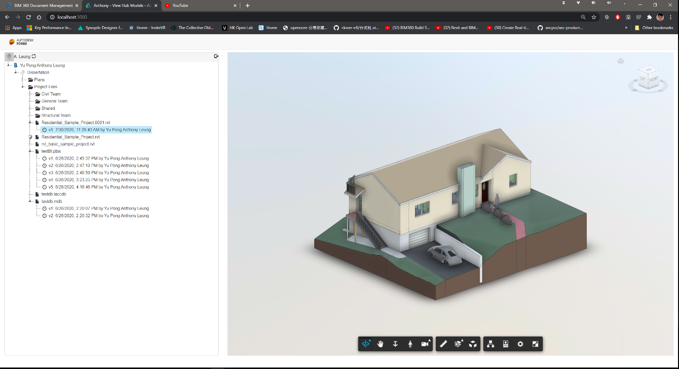

Besides, the sensor data such as humidity/temperature/Concentration of CO2, PM2.5 of indoor element is visualised with the JavaScript library Chart.js/d3. It can dynamically display sensor readings with the changing frequency of 10 seconds.

(chart)

# Functionality for Construction Professionals

To test whether the working condition is safe and healthy for the workers.

# Drawbacks

The forge API is not easy for the beginners to use. Although Autodesk can already provide different documentation on the internet, it is highly fragmented and not easy to start with. Also, some of the coding document to modify the content of the viewer application suggested from documentation which is only for the old version of the viewer application. For example, the author wants to customise the property panel of the viewer application to add customised content such as the sensory data but it is not successful.

Regarding to this issue, a visual programming interface is suggested so that the user can make use of this API to link the data or get data from other external application easily. The Author originally want to integrate the sensory data into the digital model for visualisation, however, it is very difficult to carry out this task and very less documentation to explain how to do it. As a result, the author used external library to visualise the sensory data. As capturing data by IoT device is becoming much popular, the Control Room platform should provide an easier way to integrate both the sensory data with the model data for visualisation.

# Limitation (500)

Although this study shows the ability of how the overall Control Room system to improve the project delivery, there was some limitation for this study.

# Recommendation (500 words)

-Talk more about how the integrity can be improved

=> forge is difficult to use, less documentation

=> Power BI cannot insert as card on the BIM360 platform

=> BIM360 shd with plug-in to display the sensory data /SQL data

=> weak in support external data such as sensory data

# Future works

# Conclusion

A control room can manage a good building process to build a connected city.

# Reference

Alizadehsalehi, S., Hadavi, A., & Huang, J. C. (2019). Virtual reality for design and construction education environment. *AEI 2019: Integrated Building Solutions - The National Agenda - Proceedings of the Architectural Engineering National Conference 2019*. https://doi.org/10.1061/9780784482261.023

Belizario, M. G., & Berardi, R. C. G. (2019). Use of Smart and Open Data in Smart Cities. In *25th Americas Conference on Information Systems (AMCIS 2019)*.

Boje, C., Guerriero, A., Kubicki, S., & Rezgui, Y. (2020). Towards a semantic Construction Digital Twin: Directions for future research. In *Automation in Construction*. https://doi.org/10.1016/j.autcon.2020.103179

Bolton, A., Butler, L., Dabson, I., Enzer, M., Evans, M., Fenemore, T., & Harradence, F. (2018). The Gemini Principles. *University of Cambridge, UK 2018*. https://doi.org/10.17863/CAM.32260

Brandon, J. (2020). *VR is the future of remote working*. https://www.techradar.com/news/vr-is-the-future-of-remote-working

Changali, S., Mohammad, A., & Van Nieuwland, M. (2015). The construction productivity imperative. *McKinsey Quarterly*.

Cosgrave, E. (2017). The smart city: challenges for the civil engineering sector. *Proceedings of the Institution of Civil Engineers - Smart Infrastructure and Construction*. https://doi.org/10.1680/jsmic.17.00012

Freina, L., & Ott, M. (2015). A literature review on immersive virtual reality in education: State of the art and perspectives. *Proceedings of ELearning and Software for Education (ELSE)(Bucharest, Romania, April 23--24, 2015)*. https://doi.org/10.12753/2066-026X-15-020

Harrison, C., Eckman, B., Hamilton, R., Hartswick, P., Kalagnanam, J., Paraszczak, J., & Williams, P. (2010). Foundations for Smarter Cities. *IBM Journal of Research and Development*. https://doi.org/10.1147/JRD.2010.2048257

HSE. (2019). Work-related stress , anxiety or depression statistics in Great Britain , 2019. *Annual Statistics*.

Jarrett Hendricks. (2020). *Rise of the Digital Twin: How Lessons Learned from NASA Are Changing the Way Supply Chains Are Managed*. https://info.expeditors.com/horizon/rise-of-the-digital-twin

Keil, S., Lasch, R., Lindner, F., & Lohmer, J. (2019). *A Holistic Digital Twin Based on Semantic Web Technologies to Accelerate Digitalization*.

Levine, T. (2016). *Using Communication and Collaboration Technology to Keep Construction Projects On Schedule and On Budget*.

Li, X., Yi, W., Chi, H. L., Wang, X., & Chan, A. P. C. (2018). A critical review of virtual and augmented reality (VR/AR) applications in construction safety. *Automation in Construction*. https://doi.org/10.1016/j.autcon.2017.11.003

McKinsey. (2015). The MGI Industry Digitization Index. *McKinsey Global Institute*.

McKinsey & Company. (2017). Reinventing Construction: A Route To Higher Productivity. *McKinsey & Company*.

Microsoft. (2020). *Azure Cloud Services*. https://azure.microsoft.com/en-us/overview/what-is-cloud-computing/

Mohd Nawi, M. N., Baluch, N., & Bahauddin, A. Y. (2014). Impact of fragmentation issue in construction industry: An overview. *MATEC Web of Conferences*. https://doi.org/10.1051/matecconf/20141501009

Radford, Jamie; Macdonald, J. (2020). *Project 13 Digital Transformation Workstream: Infrastructure industry benchmarking report*.

StarCompliance. (2019). *Compliance Control Room: What Is It And Who Needs It?* https://blog.starcompliance.com/control-room-what-is-it-and-who-needs-it

Stergiou, C., Psannis, K. E., Kim, B. G., & Gupta, B. (2018). Secure integration of IoT and Cloud Computing. *Future Generation Computer Systems*. https://doi.org/10.1016/j.future.2016.11.031

Woodhead, R., Stephenson, P., & Morrey, D. (2018). Digital construction: From point solutions to IoT ecosystem. *Automation in Construction*. https://doi.org/10.1016/j.autcon.2018.05.004

Xu, S., & Luo, H. (2014). The information-related time loss on construction sites: A case study on two sites. *International Journal of Advanced Robotic Systems*. https://doi.org/10.5772/58444

# Research Log

# Appendix

Coding, github

1. https://www.youtube.com/watch?v=oYzqpfinyvc